Can the Type of US Government (Divided/Unified) Affect US Prosperity?

# 

# Abstract: (Written later)

# Introduction

## Overview of US Government Structure

The United States (US) federal government is comprised of three branches: the legislative (Congress), judicial, and executive branches (President). The three branches are centered around the separation of powers. This prevents the concentration of power, divides responsibilities, and enacts checks and balances. For example, on a high level, the legislative branch consisting of the Senate and the House of Representatives drafts laws; the executive branch enforces laws; the judicial branch interprets laws. Checks and balances give each branch the authority to overturn the actions of another branch if certain criteria (or level of support within the branch) are met, so that nothing can be set into law without possibility of opposition. Essentially, for laws to be passed, they often must have little opposition or moderate to strong support amongst all branches. To understand the application of this system, it is important to understand US politics as a whole.

US politics at its core has been partisan since the beginning. Members of the legislative and executive branches are usually elected directly by the people whereas the judicial branch members or Supreme Court justices are appointed by the President of the United States. The elected officials in the legislative and executive branches usually represent parties, and these parties often have opposing agendas to one another. On the other hand, Supreme Court Justices do not represent parties, but they often have party leanings (“Supreme Court”). For this research project, we will be focusing on the legislative and executive branches because those branches are elected by the people and the members have explicit party affiliation, which will be further discussed.

The elected officials affiliated with parties often vote along party lines, support party agenda, or combat opposing parties. US politics in recent times has been bipartisan or dominated by two parties, which are the Democratic and Republican parties. The legislative and executive branches have been majority dominated by either one of two parties since 1900. In some cases, one party controls[1] the executive branch while another party controls[2] one or both chambers of Congress. This scenario is known as a divided government, and the contrasting situation when both branches are controlled by the same party is known as a unified government.

It is reasonable to hypothesize that during a divided government, passage of laws could be more difficult as the checks and balances system allows the opposing party to block the passage of laws that they do not favor. Multiple research papers have confirmed that divided governments result in less legislation being passed (Edwards 545, Howell 285). However, there is disagreement whether important legislature is affected by the situation of the government.

## Research Purpose

This research project aims to quantitatively analyze if the situation of the government can tangibly be reflected in the country’s prosperity. We hypothesize that the ability for the government to pass legislation can have significant effects on the prosperity of the country. The results of this research has the potential to shift the perception of the foundations of the US government. Does same party control benefit the country by potentially being able to enact more policies, or does the diverse set of opinions lead to more moderate policies that are better off? This research can help determine under what conditions of the US government will lead to the country thriving. The research can influence how people vote in future elections especially if they value the overall well-being of the country. Furthermore, using predictions of future elections, we may be able to use our model to predict US prosperity.

However, because the term prosperity is bold, we will analyze prosperity in economic, social, and even military terms. We will use metrics that can be used to gauge economic, social, and military prosperity. Previous research has suggested that these aspects can be affected by the type of the government. In terms of economic effects, two research articles found that trade policy is more protectionist under a divided government (Lohman 1994, Karol 2000). As seen by the ongoing trade wars with China (as of November 17, 2019), US trade policy can have significant effects on the US economy (“Stocks move lower” 2019), so it is possible that this can be reflected through economic metrics such as the US Gross Domestic Product (GDP) and the S&P 500 Stock Market Index. With respect to government spending, one study suggested that divided governments resulted higher government spending because compromises would involve satisfying differing agendas, and this would result in spending on both agendas (Alt 811-828). Moreover, when viewing social effects, divided governments may result in more social regulation debates, issues that are more personal, between the opposing factions as a way to damage the opposite party (Rose 611). This could stir more political controversy and polarize the public, and this may be reflected negatively through social metrics of government satisfaction such as government approval ratings. Furthermore, a unified government tends to respond more to public demands, which may have similar effects on government approval (Coleman 824). Finally, understanding if a divided or unified government is more likely to focus more on the military could give insight on its respective goals of projecting more or less power. Although no literature explicitly has studied this, the military may still be impacted because Congress becomes seemingly more involved in response to US military action when the government is divided (Meernik 377).

This purpose of this research project is not definitive prove causality as many of the metrics used will have external and confounding factors affecting the metrics. However, if a general trend or any significant difference can be found between divided and unified governments in any metrics, it would be a significant results as voters can have direct control over the type of government. Those who care about these significant factors would have to consider if they should vote along their traditional party lines or according to what may be best for US prosperity.

# Methodology

## Initial Consideration of Factors/Dependent Variables and Data Collection

The partisan control of each chamber in Congress and the presidency has been well-documented in government archives (“Party Division”). Using these government archives, Excel database files with detailing the party controls and time span of the control were period. The data was filtered from the year 1900 to the present[3] because the goal was to balance having adequate sample data and the applicability of the data[4].

The three aspects of prosperity that we would like to study can be classified as economic, social, and military. Because this research takes a quantitative approach to analyze if there is any sort of effect or at least some of predictive ability in respect to these aspects, we must find metrics to quantify these dependent variables that will each be tested.

The economic metrics that we collected from the website multpl.com included the Standard and Poor’s 500 Index (S&P 500) returns, US government debt, the US Gross Domestic Product (GDP), and the US Consumer Price Index (CPI). All of these metrics represent an integral part of evaluating the state of the US economy, and these (or at least some) are relatively familiar metrics to the average person. The S&P 500 measures the US stock market’s performance[5], and the Conference Board Leading Index uses it as a measure of the US economy’s health and its movements (Kenton 2019, Chappelow 2019). Moreover, the US federal government’s debt is representative of its financial health. Previous research has suggested that government spending is affected by the type of government (Alt 811-828), and this could be reflected in the debt of the US government. On the other hand, the US GDP is the dollar value of all goods and services produced by the US, and it is also a common indicator of a nation’s economic health (Kramer 2019). Finally, CPI compares the same currency amounts between different time periods. It is a closely economic monitored index and possibly concerns US citizens the most as the intrinsic value of their wealth can fluctuate and differ from its actual value. It can be used to quantify inflation or the devaluation of a currency.

The social aspects mainly focuses on government approval ratings[6] and people’s perception of the government. Gallup News contained monthly congressional approval, disapproval, and neutral percentages from 1974 to 2018. Because the goal was to study if the government type changed opinions, excluding the neutral opinions was deemed reasonable[7][8]. After recomputing the approval rating, the approval percentages were grouped by year and averaged the approval rating to obtain an annual approval rating. Because previous research suggested that the passage of legislature and even more importantly, the response to public demand was potentially affected by the situation of the government, it suggests that this could be tangibly reflected in the government approval (Coleman J. 824).

The military aspect focuses on the size of the military. David Coleman provided data from 1954 to 2014 on both the total number of military personnel and the number in each branch - Navy, Airforce, Army (Coleman D. 2014). Additional data consisting of the total number of military personnel from 2015-2017 were collected from *MacroTrends* (“U.S Military Size”). Although our initial research did not find any literature explicitly studying the effects of a unified or divided government on military size. One article did suggest an increased congressional response during divided governments, and this could be reflected in the military size during that time period.

## Preprocessing of Data

All of the data was imported into IPython notebook[9] using the pandas[10] package (Figure 2). The government type for each year was classified such that a “Unified” classification occurred when both chambers of Congress and the presidency were controlled by the same party and a “Divided” classification occurred in all other complementary cases (Figure 1).

However, directly analyzing the original data and dependent variables could be inadequate and flawed. In the case of government debt, strictly analyzing the debt value would not scale the debt for inflation. The debt values were converted to 2012 US dollars by multiplying the debt value of each year by the ratio of the CPI of 2012 to the CPI in that year, and this metric, which would give more consistent comparison, was added as a dependent variable to test. Furthermore, the yearly absolute or percent difference of each metric was computed and added as dependent variables to test because this could better reflect the changes that occurred during each congressional period, which could be caused by the type of government.

## Techniques

Beginning with simple models, linear regression was applied to identify the correlation and correlation strength between the type of government and each dependent variable. Initially, the type of government was assumed as binary (either Unified or Divided), so we were able to use a binary encoding where 0 represents “Divided” and 1 represents “Unified.” However, this encoding does not consider that divided governments can vary in degree. For example, a divided government can have either a divided Congress or a unified congress where the two chambers of Congress are controlled by different and same parties respectively. To combat this, we used a technique called one-hot encoding, which is used to distinguish between and convert categorical variable[11] into an appropriate quantitative encoding that can be analyzed. The one-hot encoding was applied to the three independent variables representing the party control in the legislative branch, Senate, and House of Representatives. The resulting multilinear[12] regression coefficients for each categorical variable not only allows quantifies the potential effects of the type of government, but it also can provide insight on partisan effect on each of these variables. For example, the effects of a Democratic unified government could greatly from a Republican unified government.

The next idea was to implement k-means clustering [13] for each dependent variable where each cluster would represent either situations unified or divided governments. Unfortunately, there seems to be no clear way to find an independent variable that would not already pre-label the cluster. This would immense overfit and give no predictive power or insight.

Following the idea of k-means clustering, implementing decision trees[14] seemed like another plausible and insightful approach. The goal was to gauge the accuracy of identifying the type of government based on a combination of the dependent variables from before. The binary nature of the type of government also motivated the application of decision trees. The conditional nodes could give insight on which dependent variables are significant and even what types of situations likely result in unified or divided governments giving more insight into the dependent variables. Cross validation techniques and max depth parameters were performed and implemented to prevent overfitting and increase the interpretability of the resulting tree, respectively.

# Results

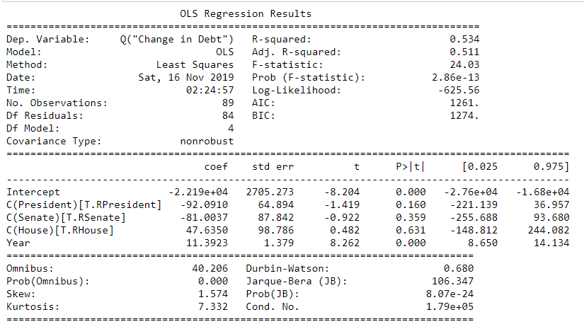

# 

# 

# Conclusion

# Improvements

* Include presidential approval
* Number of conflicts
* Inconsistency of years
* Military spending
* Change between divided and unified government transitions
* Testing to understand when the effects will take place (may not happen immediate)
* Unified and Divided aren’t all created equal especially divided
* Increased GPU so that more ML models can be ran
* Implement deep learning

# Citations

1. Alt, James E., and Robert C. Lowry. “Divided Government, Fiscal Institutions, and Budget Deficits: Evidence from the States.” American Political Science Review, vol. 88, no. 4, 1994, pp. 811–828., doi:10.2307/2082709.
2. Chappelow, Jim. “Composite Index of Leading Indicators Definition.” Investopedia, Investopedia, 11 Oct. 2019, [www.investopedia.com/terms/c/cili.asp](http://www.investopedia.com/terms/c/cili.asp).
3. Coleman, David. “U.S. Military Personnel 1954-2014: The Numbers.” History in Pieces, 30 July 2014, historyinpieces.com/research/us-military-personnel-1954-2014.
4. Coleman, John J. “Unified Government, Divided Government, and Party Responsiveness.” The American Political Science Review, vol. 93, no. 4, 1999, pp. 821–835. JSTOR, [www.jstor.org/stable/2586115](http://www.jstor.org/stable/2586115).
5. “Congress and the Public.” Gallup.com, Gallup, 12 Nov. 2019, news.gallup.com/poll/1600/congress-public.aspx.
6. Edwards, George C., et al. “The Legislative Impact of Divided Government.” American Journal of Political Science, vol. 41, no. 2, 1997, pp. 545–563. JSTOR, [www.jstor.org/stable/2111776](http://www.jstor.org/stable/2111776)
7. Howell, William, et al. “Divided Government and the Legislative Productivity of Congress, 1945-94.” Legislative Studies Quarterly, vol. 25, no. 2, 2000, pp. 285–312. JSTOR
8. Karol, David. “Divided Government and U.S.Trade Policy: Much Ado About Nothing?” *International Organization*, vol. 54, no. 4, 2000, pp. 825–844., doi:10.1162/002081800551389.
9. Kenton, Will. “S&P 500 Index – Standard & Poor's 500 Index Definition.” *Investopedia*, Investopedia, 23 Oct. 2019, [www.investopedia.com/terms/s/sp500.asp](http://www.investopedia.com/terms/s/sp500.asp).
10. Kramer, Leslie. “What Is GDP and Why Is It So Important to Economists and Investors?” Investopedia, Investopedia, 9 Nov. 2019, www.investopedia.com/ask/answers/what-is-gdp-why-its-important-to-economists-investors/.
11. Lohmann, Susanne, and Sharyn O’Halloran. “Divided Government and U.S. Trade Policy: Theory and Evidence.” International Organization 48, no. 4 (September 1994): 595. doi:10.1017/S0020818300028320
12. Meernik, James. “Congress, the President, and the Commitment of the U. S. Military.” Legislative Studies Quarterly, vol. 20, no. 3, 1995, pp. 377–392
13. “Party Division.” U.S. Senate, United States Federal Government, 3 Jan. 2019, www.senate.gov/history/partydiv.htm.
14. Rose, Melody. “Divided Government and the Rise of Social Regulation.” Policy Studies Journal, vol. 29, no. 4, Dec. 2001, p. 611. EBSCOhost, doi:10.1111/j.1541-0072.2001.tb02113.x.
15. “Separations of Power--An Overview.” *Separation of Powers--An Overview*, National Conference of State Legislatures, 1 May 2019, [www.ncsl.org/research/about-state-legislatures/separation-of-powers-an-overview.aspx](http://www.ncsl.org/research/about-state-legislatures/separation-of-powers-an-overview.aspx).
16. “Supreme Court of the United States.” *Ballotpedia*, Ballotpedia, ballotpedia.org/Supreme_Court_of_the_United_States.
17. “Stocks Move Lower as Trade War Anxiety Lingers.” USA Today, Gannett Satellite Information Network, 12 Aug. 2019, www.usatoday.com/story/money/2019/08/12/stock-market-global-stocks-gain-amid-us-china-trade-war-fears/1984586001/.
18. Swanson, Ana. "Trump's Trade War With China Is Officially Underway". The New York Times. Retrieved May 26, 2019.
19. “U.S. Military Size 1985-2019.” *MacroTrends*, www.macrotrends.net/countries/USA/united-states/military-army-siz.

Appendix

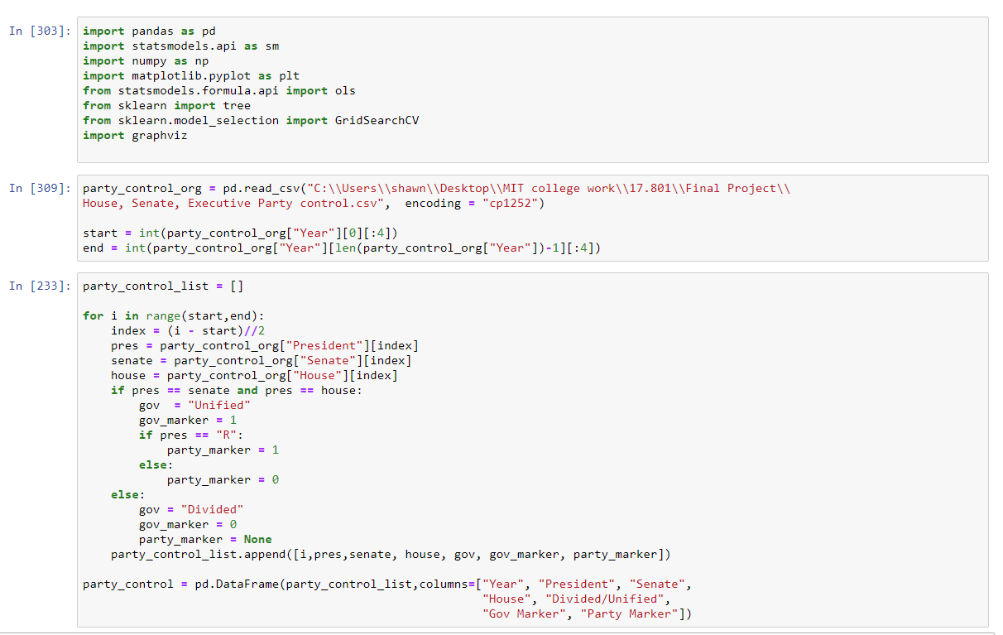

Figure 1: Python packages used and Python classifier for the type of government

Figure 2: Loading data from csv/Excel files to be analyzed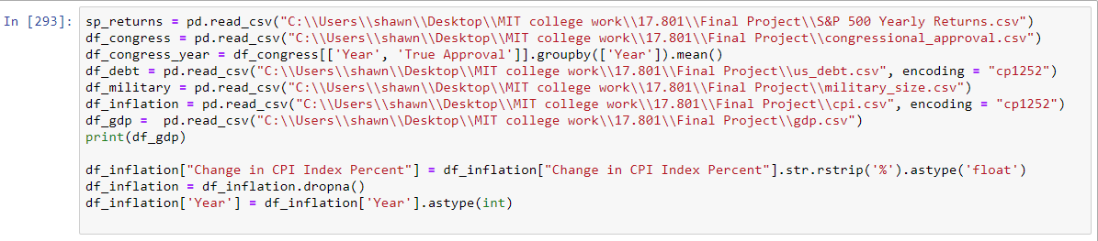

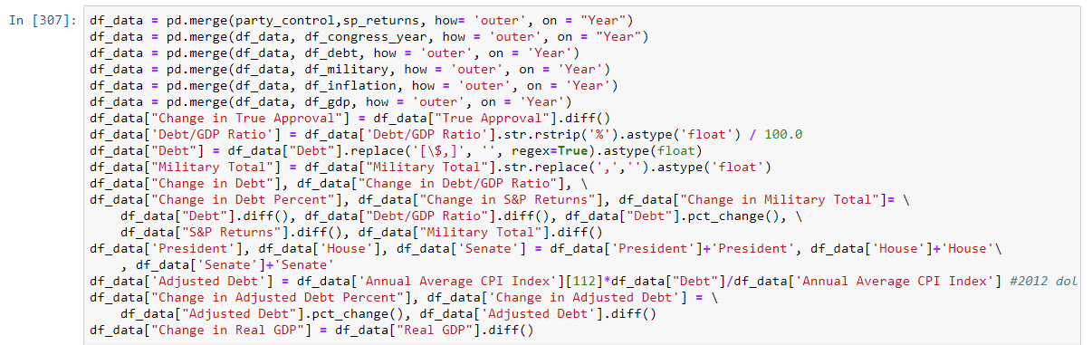

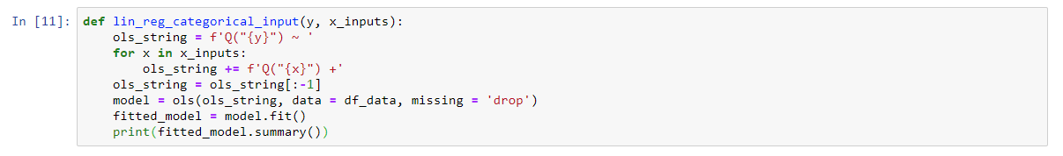

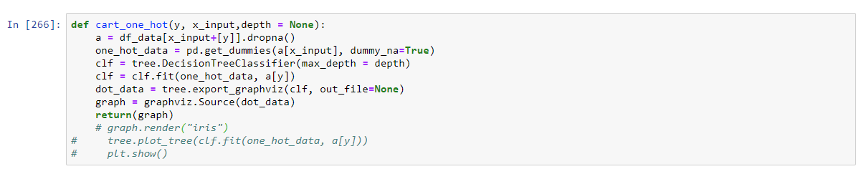

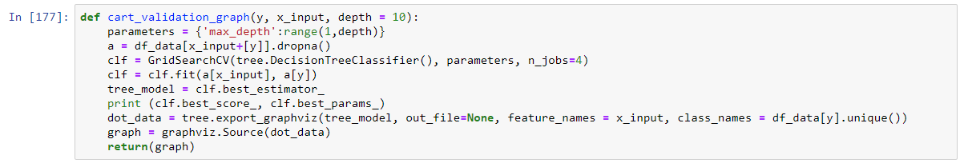

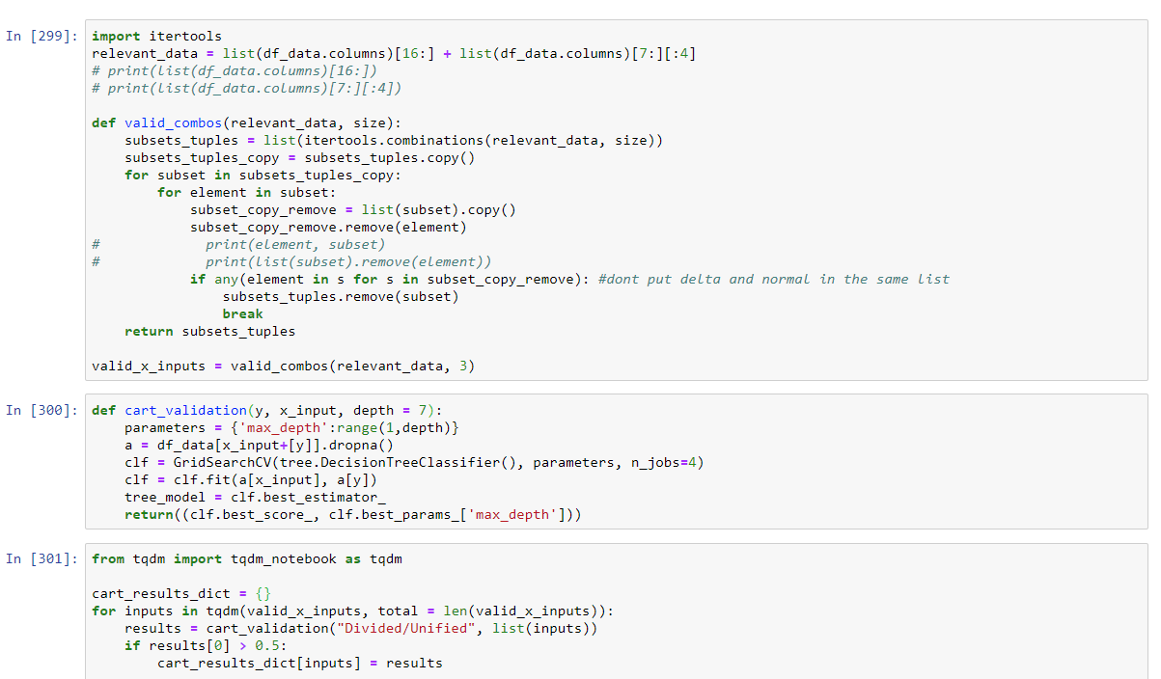

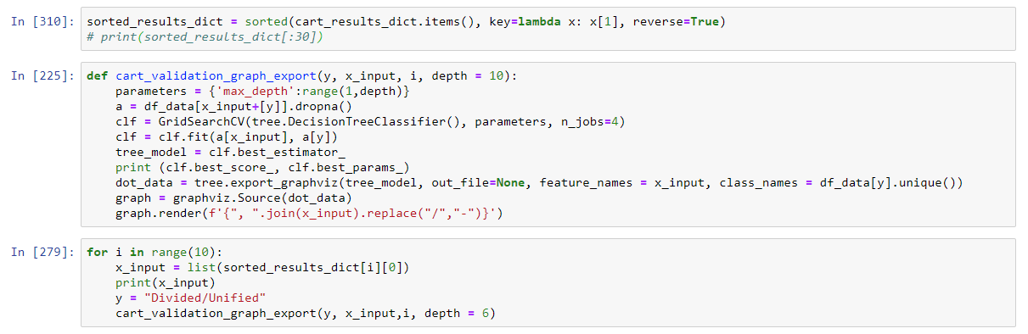

1. Control means the president represents the controlling party
2. Control means the controlling party having majority of the seats in the respective chamber of Congress
3. Year 2018 since 2019 has not ended at the time of writing this so some statistics cannot be gathered accurately
4. Older than 1900 is likely not applicable today as much has changed since then
5. Aggregates the performances of 500 of the largest US companies
6. Percentage of people who approve of the government
7. Would be equivalent to rating each positive as +1, neutral as 0, and negative as -1
8. Neutral opinions comprised of around 6% of the total responses
9. Commonly used interact interface for Python
10. Python software library that can visualize data in tables and analyze them
11. Categorical variables are not numerical variables and usually have limited, discrete combinations. For example, the variable for political parties can be either “R” or “D.”
12. Regression model that includes more than one independent variable
13. A machine learning technique designed to cluster or group points that are close to one another on a scatter plot together. It is can be used to classify
14. An algorithm that can be used to classify something based on following a tree/flowchart with each node being a true/false statement based on the parameters and each branch as following the condition of the node